Neural network

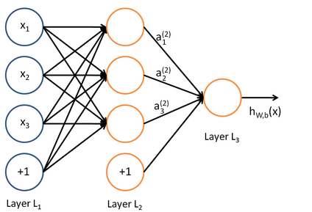

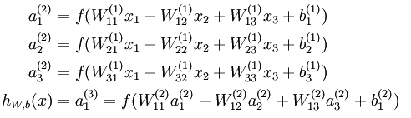

Forward propagation

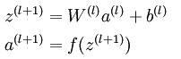

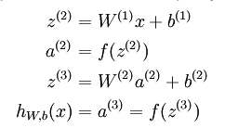

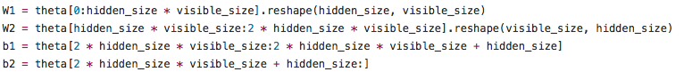

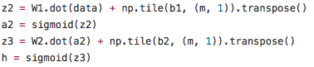

螢幕快照%202017-02-16%20下午5.05.35.png

Cost function

螢幕快照%202017-02-16%20下午3.24.03.png

Cost function with regularization

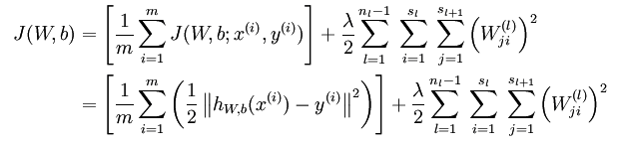

螢幕快照%202017-02-16%20下午4.25.00.png

Cost function with sparsity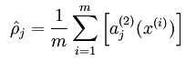

螢幕快照%202017-02-16%20下午4.23.46.png

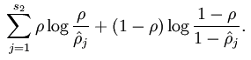

螢幕快照%202017-02-16%20下午4.51.33.png

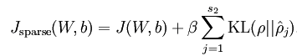

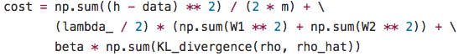

Sparse autoencoder with backpropagation

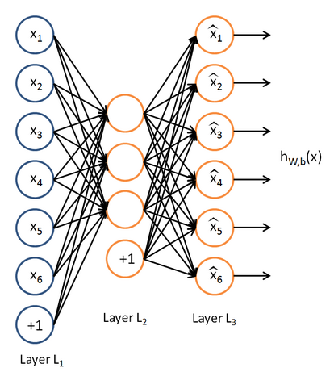

Output layer(layer3)

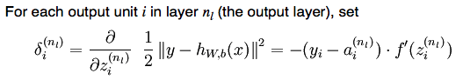

螢幕快照%202017-02-16%20下午3.28.41.png

螢幕快照%202017-02-16%20下午4.41.30.png

Hidden layer(layer2)

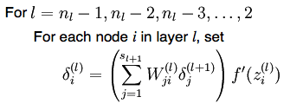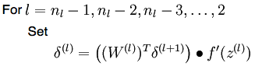

螢幕快照%202017-02-16%20下午4.43.27.png螢幕快照%202017-02-16%20下午4.43.40.png

Hidden layer with sparsity

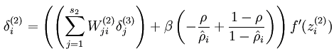

螢幕快照%202017-02-16%20下午4.33.13.png

螢幕快照%202017-02-16%20下午4.41.47.png

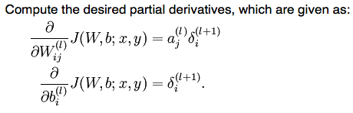

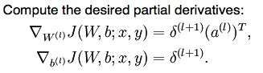

Iteration step

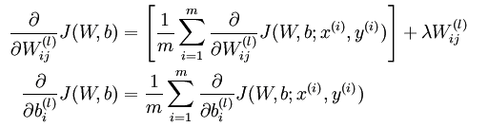

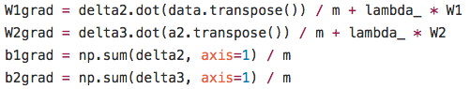

Update weighting

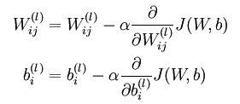

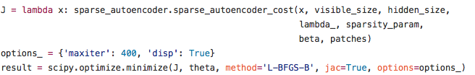

螢幕快照%202017-02-16%20下午3.56.27.png